**DHCP is my friend! It allows automatic distribution of IP addresses and communication of DNS servers to devices on the network. If I didn’t have DHCP, I would have to do everything manually, which is a no-no for time and scalability reasons.**

1. Navigate to the router’s web interface by typing its ip address. This address varies, but 192.168.1.1 and 10.0.0.1 are common.

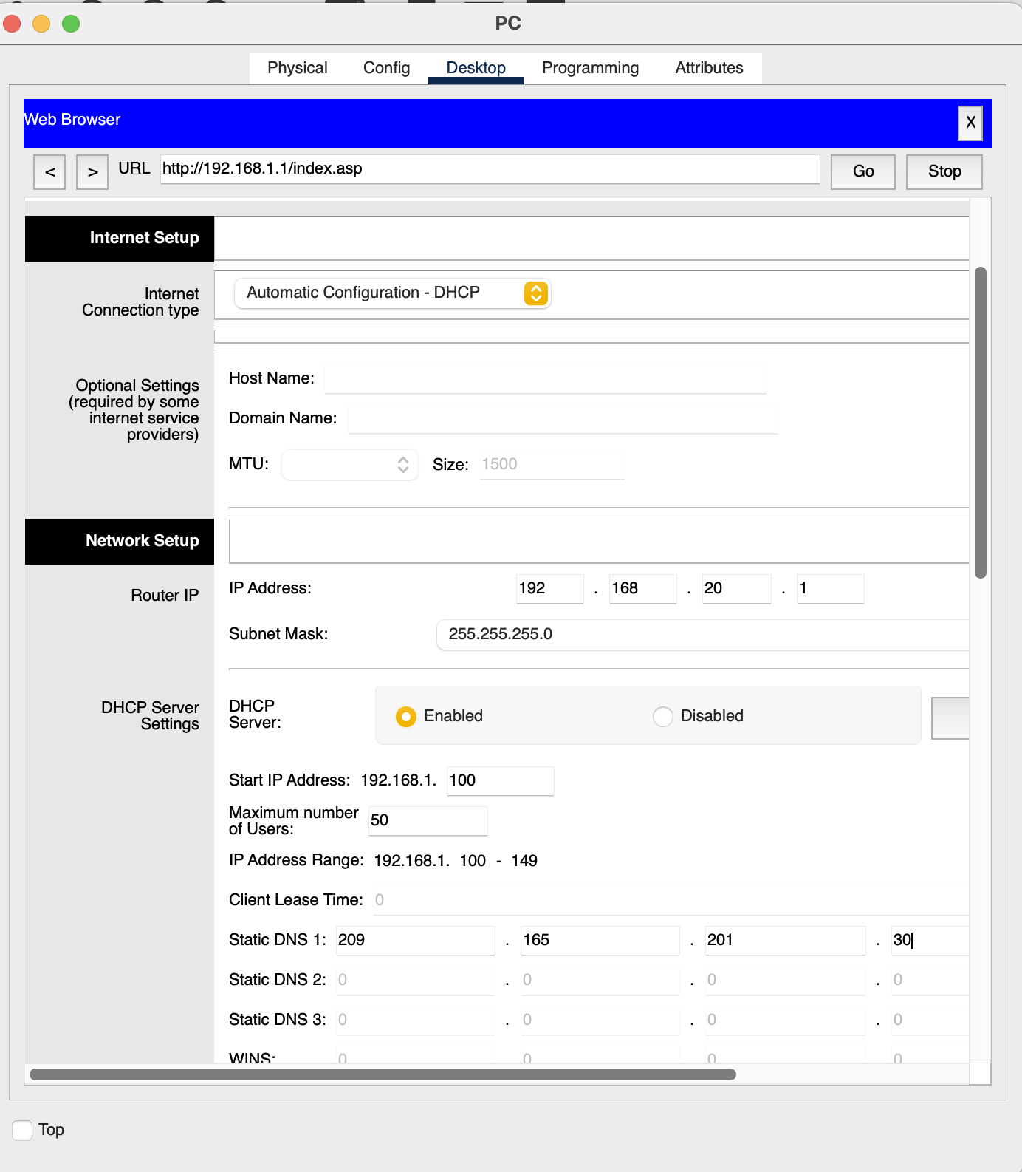

1. Add in the router’s IP and the range of IP addresses that I want DHCP to hand out.



1. If I change the network ID of the router (as I did in the image above), then the end device will stop communicating with the router because they are no longer on the same subnet! This also means that I can no longer configure the router through the web interface. I decided to statically change the IP of the end device, so that I could access the web interface again. It worked! See the process below.

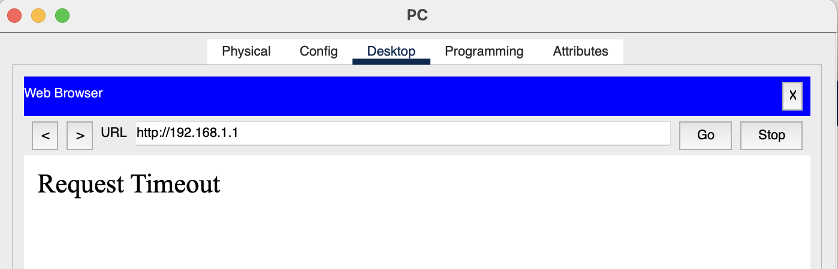

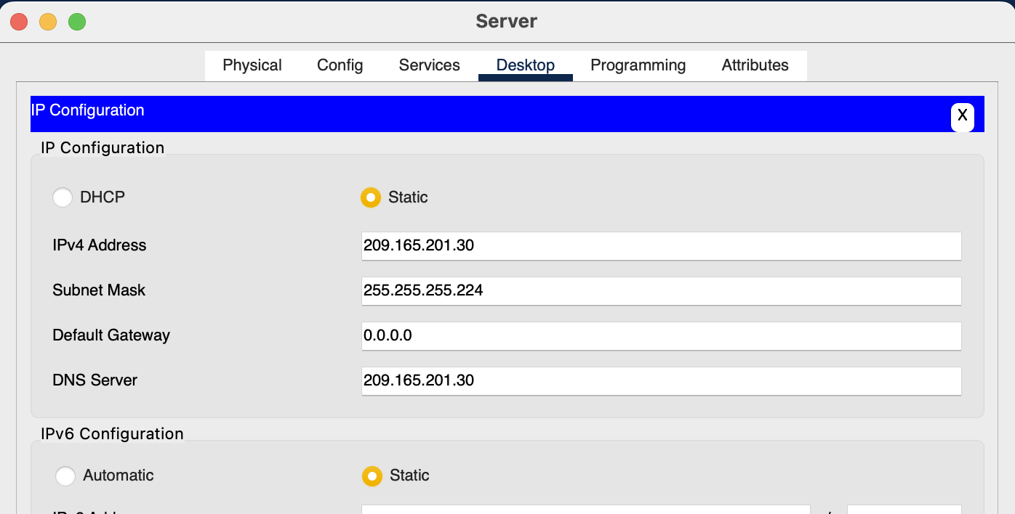

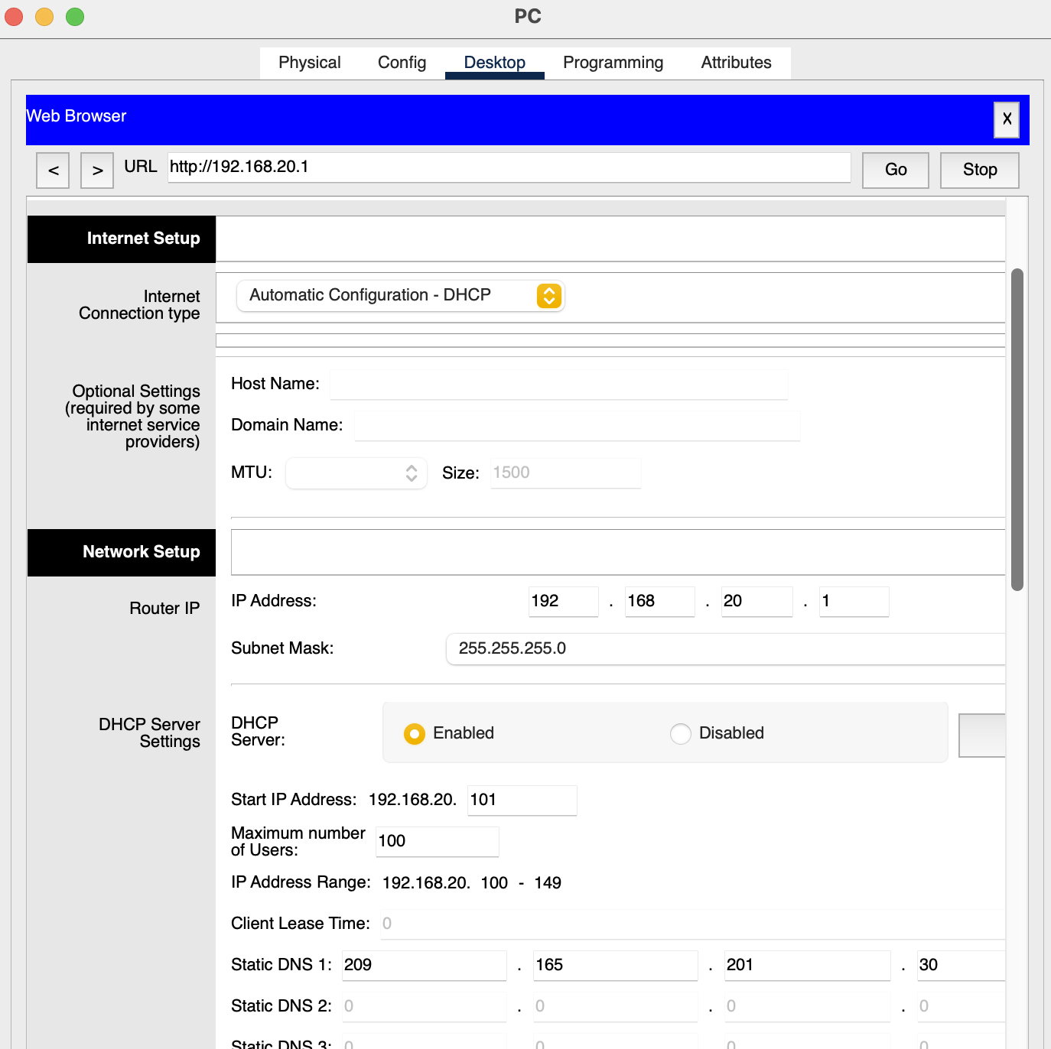

1. Once finished I changed the end device to respond to DHCP. This is preferred behavior to allow the server to automatically reassign an IP address, if needed, in the future. I actually noticed that I originally got the first message, but shortly after got the last message.

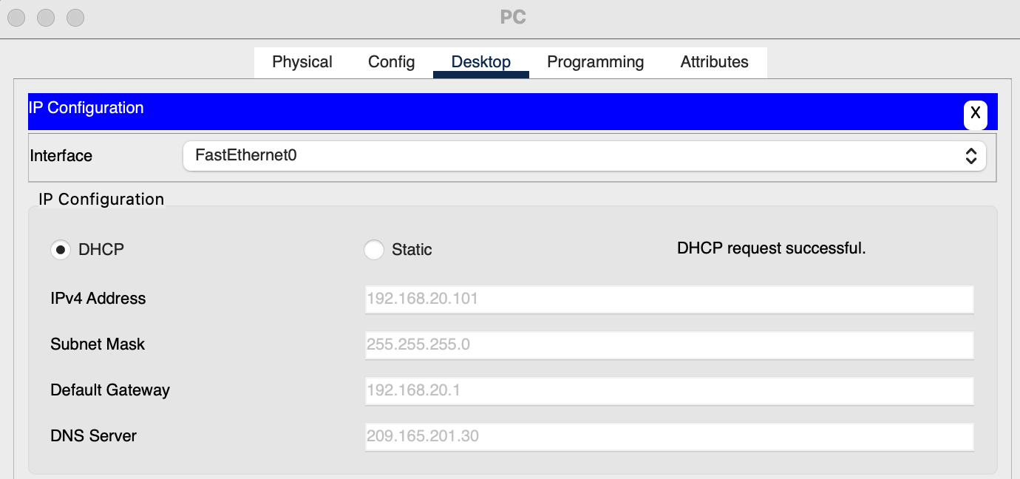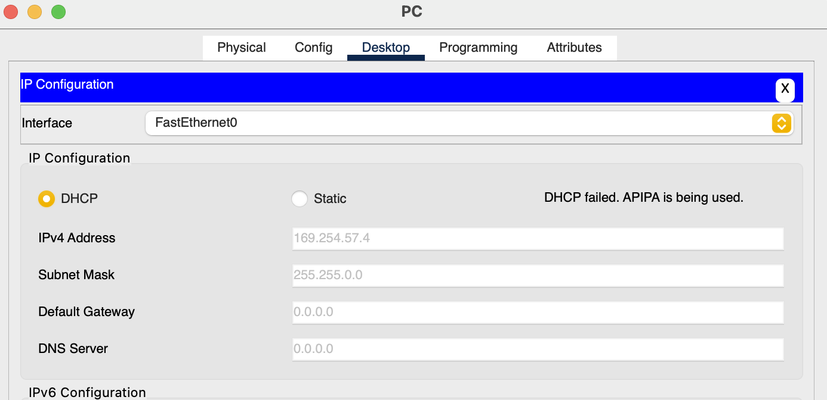

So, patience is a necessary tool in this process as well.